**ASSIGNMENT 1 FRONT SHEET**



|  |  |  |  |
| --- | --- | --- | --- |
| **Qualification** | **BTEC Level 5 HND Diploma in Computing** | | |
| **Unit number and title** | Unit 06: Managing a Successful Computing Project | | |
| **Submission date** | 9/10/2022 | **Date Received 1st submission** |  |
| **Re-submission Date** |  | **Date Received 2nd submission** |  |
| **Student Name** | Mai The Duc | **Student ID** | GCH200681 |
| **Class** | GCH0907 | **Assessor name** | Nguyen The Lam Tung |
| **Student declaration**  I certify that the assignment submission is entirely my own work and I fully understand the consequences of plagiarism. I understand that making a false declaration is a form of malpractice. | | | |
|  |  | **Student’s signature** |  |

**Grading grid**

|  |  |  |  |  |  |  |
| --- | --- | --- | --- | --- | --- | --- |
| P1 | P2 | P3 | P4 | M1 | M2 | D1 |
|  |  |  |  |  |  |  |

|  |  |  |
| --- | --- | --- |
| **❒ Summative Feedback: ❒ Resubmission Feedback:** | | |
| **Grade:** | **Assessor Signature:** | **Date:** |
| **IV Signature:** | | |

Table of Contents

Introduction 4

II. Project Initialization 5

III. Project Management Plan 5

1. Scope 5

2. Time 6

3. Communication 6

4. Risks 6

5. Resources 7

6. Cost estimation 7

III. Planning 9

1. WBS 9

2. Gantt Chart 10

IV. Research 11

1. Primary Research 11

2. Secondary research 14

References 17

# Introduction

In the early twenty-first century, we saw the sweeping changes brought on by the digital transformation. Digital devices play a significant role in human life; they make managing our work and personal affairs easier and more productive. But as everything has shown, the digital transformation has its own set of environmental issues. Increased CO2, greater overall electricity consumption, the removal of trees for additional dams, etc. are some examples of negative outcomes. Additionally, technology is constantly evolving, so as the digital revolution advances, we will leave behind a significant amount of outdated technology. Therefore, if we are unable to recycle them, it will also be a problem for the environment.

As a part of the research and development team, we will create solar electricity using solar batteries in this mini-project to lessen environmental damage. By using this renewable energy, we can avoid destroying forests and natural habitats to build more dams.

# II. Project Initialization

This project started with baby steps. Our solar-powered batteries will be installed on the university's campus roof. Additionally, if this project is a success, we can expand it into other university communities.

Our objectives are to:

- Supply the campus with green electricity.

- Prevent using hydroelectricity to preserve the environment.

- Save money over time for the campus.

# III. Project Management Plan

## Scope

We initially only intended for the scope of this project to include Greenwich University; however, we may later think about expanding it. As long as they are on campus, everyone who belongs to Greenwich, including visitors, can use the energy from renewable source.

To convert solar thermal energy into electrical power, we will need solar panels. It will be positioned a top the building's roof. We'll purchase a large quantity of solar panels—enough to power the entire structure.

The headmaster must approve and provide funding for us. Additionally, we must pick a time when no students are present to transport and install panels. In order to evaluate the topic, we will interview and survey students after implementation.

## Time

This project will took 2 months to plan, 3 months to develop, and 1 last month to testing.

The first phase is planning, our team need prepare everything to the headmaster. We will present the problem about digital transformation and the damage to environment. Then we introduce the solar panel and it’s advantage. Lastly, we will explain the project implementation.

Phase 2 is implement these panel and configure the whole system. We will install wire and a system to control and manage these panels. After that, we will testing in a small amount of time and then we will use this system for the building.

Phase 3, In the testing phase, we will try using electronic devices on the top floor using this new system. After some serious test, we will use this solar energy power to provide electricity for the whole building.

## Communication

Our teams use group chat to have discussions. We use apps like Discord, Messager, and Zalo, among others. If there is time, we will congregate and meet in person.

We communicate with one another very frequently on the platforms mentioned above.

## Risks

|  |  |  |  |  |
| --- | --- | --- | --- | --- |
| Category | Risk | Probability | Priority | Suggestion/Action |
| Technology | Technology obsolescence | Low | Medium | We need to upgrade the system. |
| Quality | Product reliability issues | Low | Low | The product will perform well and reliable. Or else we will fix it. |
| Quality | Product have low durability | Medium | Medium | We will need to maintain the product carefully and casually. |
| Schedule | Task overdue | Medium | Low | Is ok of us to be little late because we always have spare time. |
| Resource | Low skill member | High | High | Almost all member still new for this kind of project. But give us time, we will give all our effort to this project. |
| Resource | Not enough resource | Medium | High | The project won’t be able to lunch if we lack of equipment and tools. |
| Budget | Task budget overrun | High | High | We will need to ask for donation from other interested source. |
| Budget | Wrong budget estimate of a task | Low | High | Low chance, we could have a problem when accounting for task budget. Therefor, the planning step is very important. |

## Resources

To power the entire building, we will require at least 12 to 15 solar batteries. Dashboard is also necessary for system management. My whole team has 8 people, but 2 of them are on another project so we only have 6 left. The team with 6 people, had to work together to complete this project.

We will need 2 members to purchase and transport solar panels.

Implement the system need 3 members. 2 of them have to make the plan to install. Then 5 member above will transport and install panels. After that, 3 members from implement team will test the system.

The last person will make interview and survey to document this project.

## Cost estimation

We applied the three-point estimating method to calculate the total cost for the whole project.

According to Dashore (2021), we use three estimates to define an approximate range for a project cost:

* Most likely (M) as know as best guest (BG): The cost of the activity, based on a reasonable estimate of the required work's effort and any anticipated costs.
* Optimistic (O): Based on an analysis of the activity's best-case scenario, the activity's cost was determined.
* Pessimistic (P): Based on an analysis of the worst-case scenario for the activity, the cost was calculated.

So to be fair, I use Beta Distribution formula to calculate the cost of project:

E = (4M + O + P) / 6

* E = (4 x 120000 + 103000 + 150200) / 6 = 122200$

So 122200$ is our final cost plan and we operate the project around it.

|  |  |
| --- | --- |
| Name | Cost |
| Man-Month (x6) | 1200 x 6 x 6 (months) = 43200$ |
| Solar batteries (x12) | 5000 x 12 = 60000$ |
| Electricity cable | 10000$ |
| Dashboard and other control stuff | 3000$ |
| Other tools | 6000$ |
| **Total** | 122200$ |

We will operate this project from February to August of 2023.

On the third month will need 67200& to buy solar panels and transport it to the campus. In that time we will need to rebuild the roof for space.

Every month after that, we will install these panels following as the plan.

# III. Planning

## WBS

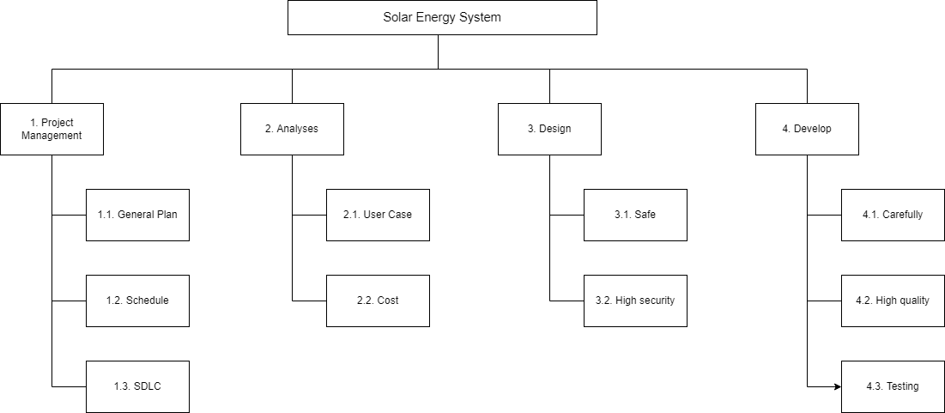

+) First is Project management  
This section content a general plan, a schedule plan, and a system development life circle. We need to make plan in detail and carefully.

+) Second is Analyses  
Analyses about user case and cost plan. We do not want any trouble with over cost of the project.

+) Third is Design  
We will need to design bonus safe method and security. We want a safe system to fixing and upgrading in the future. The system needs to be security secure too.

+) Lastly us Develop  
We will install it carefully and with our very best quality to do the job. Testing will be the last step before using it officially for the building.

## Gantt Chart

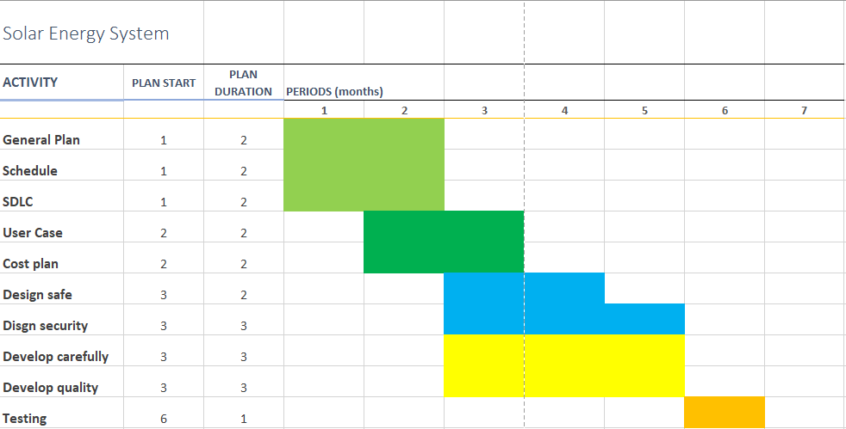

+) 2 first month to make plan

A general plan will be a need for this project. And a schedule plan will be great to manage this project. SDLC are important but still can change on the time we develop the system.

+) month 2 and 3 we make cost and user case plan

Cost plan will be made carefully for a successful project. Also, user case will be explain.

+) Month 3 to 5 we install the panels

A lot of panels make us 3 months to finish. There is a security system develop with the main electric system.

+) Last month is testing

Testing requires us to focus and detail tests will be made.

# IV. Research

## Primary Research

1. List of interview question

This interview will help us answer the question of digital transformation impact on environment and our solar system energy.

1. On the scale of 1-5, how much do you care about digital transformation. (open question)

⭘ 1 ⭘ 2 ⭘ 3 ⭘ 4 ⭘ 5

1. Do you think digital transformation have negative impact on environment. (close question)  
   A. Yes B. No
2. Do you like our project on solar system energy. (close question)

A. Yes B. No

1. On the scale of 1-5, how exciting do you want to use solar electric power. (open question)

⭘ 1 ⭘ 2 ⭘ 3 ⭘ 4 ⭘ 5

1. Do you think our project will make any change to environment? (open question)
2. Summary

On the first question:

|  |  |
| --- | --- |
|  | Votes |
| Option 1 | 1 |
| Option 2 | 3 |
| Option 3 | 1 |
| Option 4 | 3 |
| Option 5 | 2 |

On the second question:

We are astonished that 8 out of 10 people surveyed respond negatively to the question. That means, most people do not really see the damage of digital transformation on nature environment.

On the third question:

We are happy to tell that, 90% really like our idea and the other 10% are very interested.

On the fourth question:

|  |  |
| --- | --- |
|  | Votes |
| Option 4 | 8 |
| Option 5 | 2 |

On the last question:

Well, in this fifth question, we receive a lot of different answer. But all of them kind of curious about the solar system, and the rest is exciting about it.

1. List of survey questions

This survey will ask about our solar system energy. We want student and everyone else to share the feeling about our project.

1. On the scale of 1-5, how much do you care about digital transformation negative impact on environment. (open question)  
   ⭘ 1 ⭘ 2 ⭘ 3 ⭘ 4 ⭘ 5
2. Do you think solar energy system will solve anything? (open question)
3. Do you agree about our method. (open question)
4. On the scale of 1-5, do you like to change all of the electricity source in your life to reusable source. (open question)  
   ⭘ 1 ⭘ 2 ⭘ 3 ⭘ 4 ⭘ 5
5. Do you think our project will make any change to environment? (open question)
6. Summary

On the first question:

|  |  |
| --- | --- |
|  | Votes |
| Option 1 | 2 |
| Option 2 | 1 |
| Option 3 | 6 |
| Option 4 | 1 |
| Option 5 | 1 |

On the second question:

All of the answer are positive.

On the third question:

Almost everyone thinks our method are great but small amount think they prefer electric from wind energy.

On the fourth question:

|  |  |
| --- | --- |
|  | Votes |
| Option 1 | 4 |
| Option 5 | 6 |

On the last question:

Like the interview, the answer are likely similar.

1. Evaluate

Through interview and survey, we have a bigger look about digital transformation impact on environment. Some people still lack of awareness about this problem. We have a chance to introduce about our project to help them know more about it. It been really an experience when we operate this section.

Interview have 5 questions  
Survey have 5 questions

With the interviews and surveys, we collected and learning a lot from other students. We have noted and remember to improve from this project.

## Secondary research

Book research:

1. Beside of bad things happened to environment, digital transformation do have huge impact on economy. All the information are written in Digital Transformation of the Economy: Challenges, Trends and New Opportunities

2. Back to the negative impact on environment of digital transformation, the book Digital Transformation and Global Society have mentioned it. It also explain about budget expenditures for environmental protection.

Both book are different but my best thought about digital transformation are:

Transformation is a need for the era of digital.

Environment may be damage a lot so we must also protect our planet.

We need to teach children about this problem and together find the new future to healthy humankind.

Article research:

1. “The Impact of Digital Transformation on Environmental Sustainability” by Thanh Cong Truong on 17th May 2022

Students will be asked to assess the effects of digital technologies on the environment, which can be either positive or negative. Main effects of the direct and indirect environmental impacts of digital transformation were distinguished. The mining and extraction of natural resources needed for hardware products are the main contributors to resource depletion and global warming. The authors argued that the production of ICT machinery and devices is among the sources contributing to the increasing levels of CO2 emissions. With respect to waste management and handling, digital solutions have been discussed as forecasting the waste generation, unveiling resource waste, or designing more efficient waste management models.

The accumulation of waste is a major environmental problem due to rapid urbanisation and population growth. Proper management and handling of waste are essential for any country to prevent pollution and reduce the risks to public health. Digital transformation can help develop new coping methods with waste on enormous scales.

2. “Digital Transformation and Environmental Sustainability: A Review and Research Agenda” by Abul Karim Feroz and other researchers on 1st February 2021

Pollution control warrants special attention as the environment and human health are under direct threat from pollutants emitted into surface water due to rapid urbanization. Digital technologies enable significant disruptions in air pollution, carbon emission, wastewater treatment, disaster management, and climate change. The use of artificial intelligence for environmental pollution control proliferates. Social media has been used to measure the impacts of air pollution and disaster management. We came across studies using mobile technologies for pollution control. IoT sensors demonstrate great potential as an effective tool to understand the PM2.5 plume movement with temporal variation and geo-specific location, which can lead to better air quality.

Digital technologies enable significant disruptions in air pollution, carbon emission, wastewater treatment, disaster management, and climate change. Social media has been used to measure the impacts of air pollution and disaster management. IoT sensors demonstrate great potential as an effective tool to understand PM2.5 plume movement with temporal variation and geo-specific location. Big data is also gaining popularity in waste management and recycling. Other digital technologies such as IoT, cloud computing, and social media are also transforming the waste management arena.

3. “Digital Technologies Are Part of the Climate Change Problem” in ICTworks community on 20th February 2020

Initiatives such as Restart are important in trying to change the mentality of consumers, and thereby companies and governments. Most of the sector is based on the fundamental concept of replacement rather than repair. They note that the average mobile creates 55 kilos of carbon emissions in manufacture, equal to 26 weeks of laundry.

Despite efforts to recycle digital technology, e-Waste remains a fundamental problem for the sector. Much e-waste contains concentrated amounts of potentially harmful products, and this shows little sign of abating. In 2014 41.8 million tons of discarded electrical and electronic waste was produced, little of which was collected for recycling.

# References

Abdul Karim Feroz, H. Z. A. C., 2021. *Digital Transformation and Environmental Sustainability: A Review and Research Agenda.* [Online]   
Available at: https://www.mdpi.com/2071-1050/13/3/1530/htm  
[Accessed 29 Octorber 2022].

Anonymous, 2020. *Digital Technologies Are Part of the Climate Change Problem.* [Online]   
Available at: https://www.ictworks.org/digital-technologies-climate-change-problem/  
[Accessed 29 Octorber 2022].

Daniel A. Alexandrov, A. V. B. A. V. C. Y. K. O. K. I. M., 2019. *Digital Transformation and Global Society.* 4th ed. Petersburg: Spinger.

Dashore, A., 2021. *Methods of Cost Estimation in Projects.* [Online]   
Available at: https://theconstructor.org/construction/methods-cost-estimation/36532/  
[Accessed 9 October 2022].

Svetlana Ashmarina, A. M. M. V., 2019. *Digital Transformation of the Economy: Challenges, Trends and New Opportunities.* 3th ed. Lodon: springer.

Truong, T. C., 2022. *The Impact of Digital Transformation on Environmental Sustainability.* [Online]   
Available at: https://www.hindawi.com/journals/am/2022/6324325/  
[Accessed 29 Octorber 2022].